 |  | 
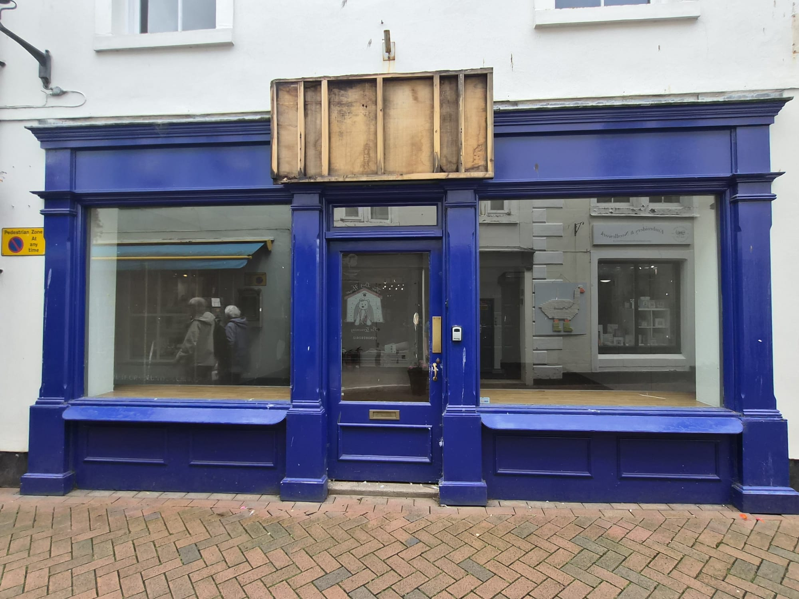
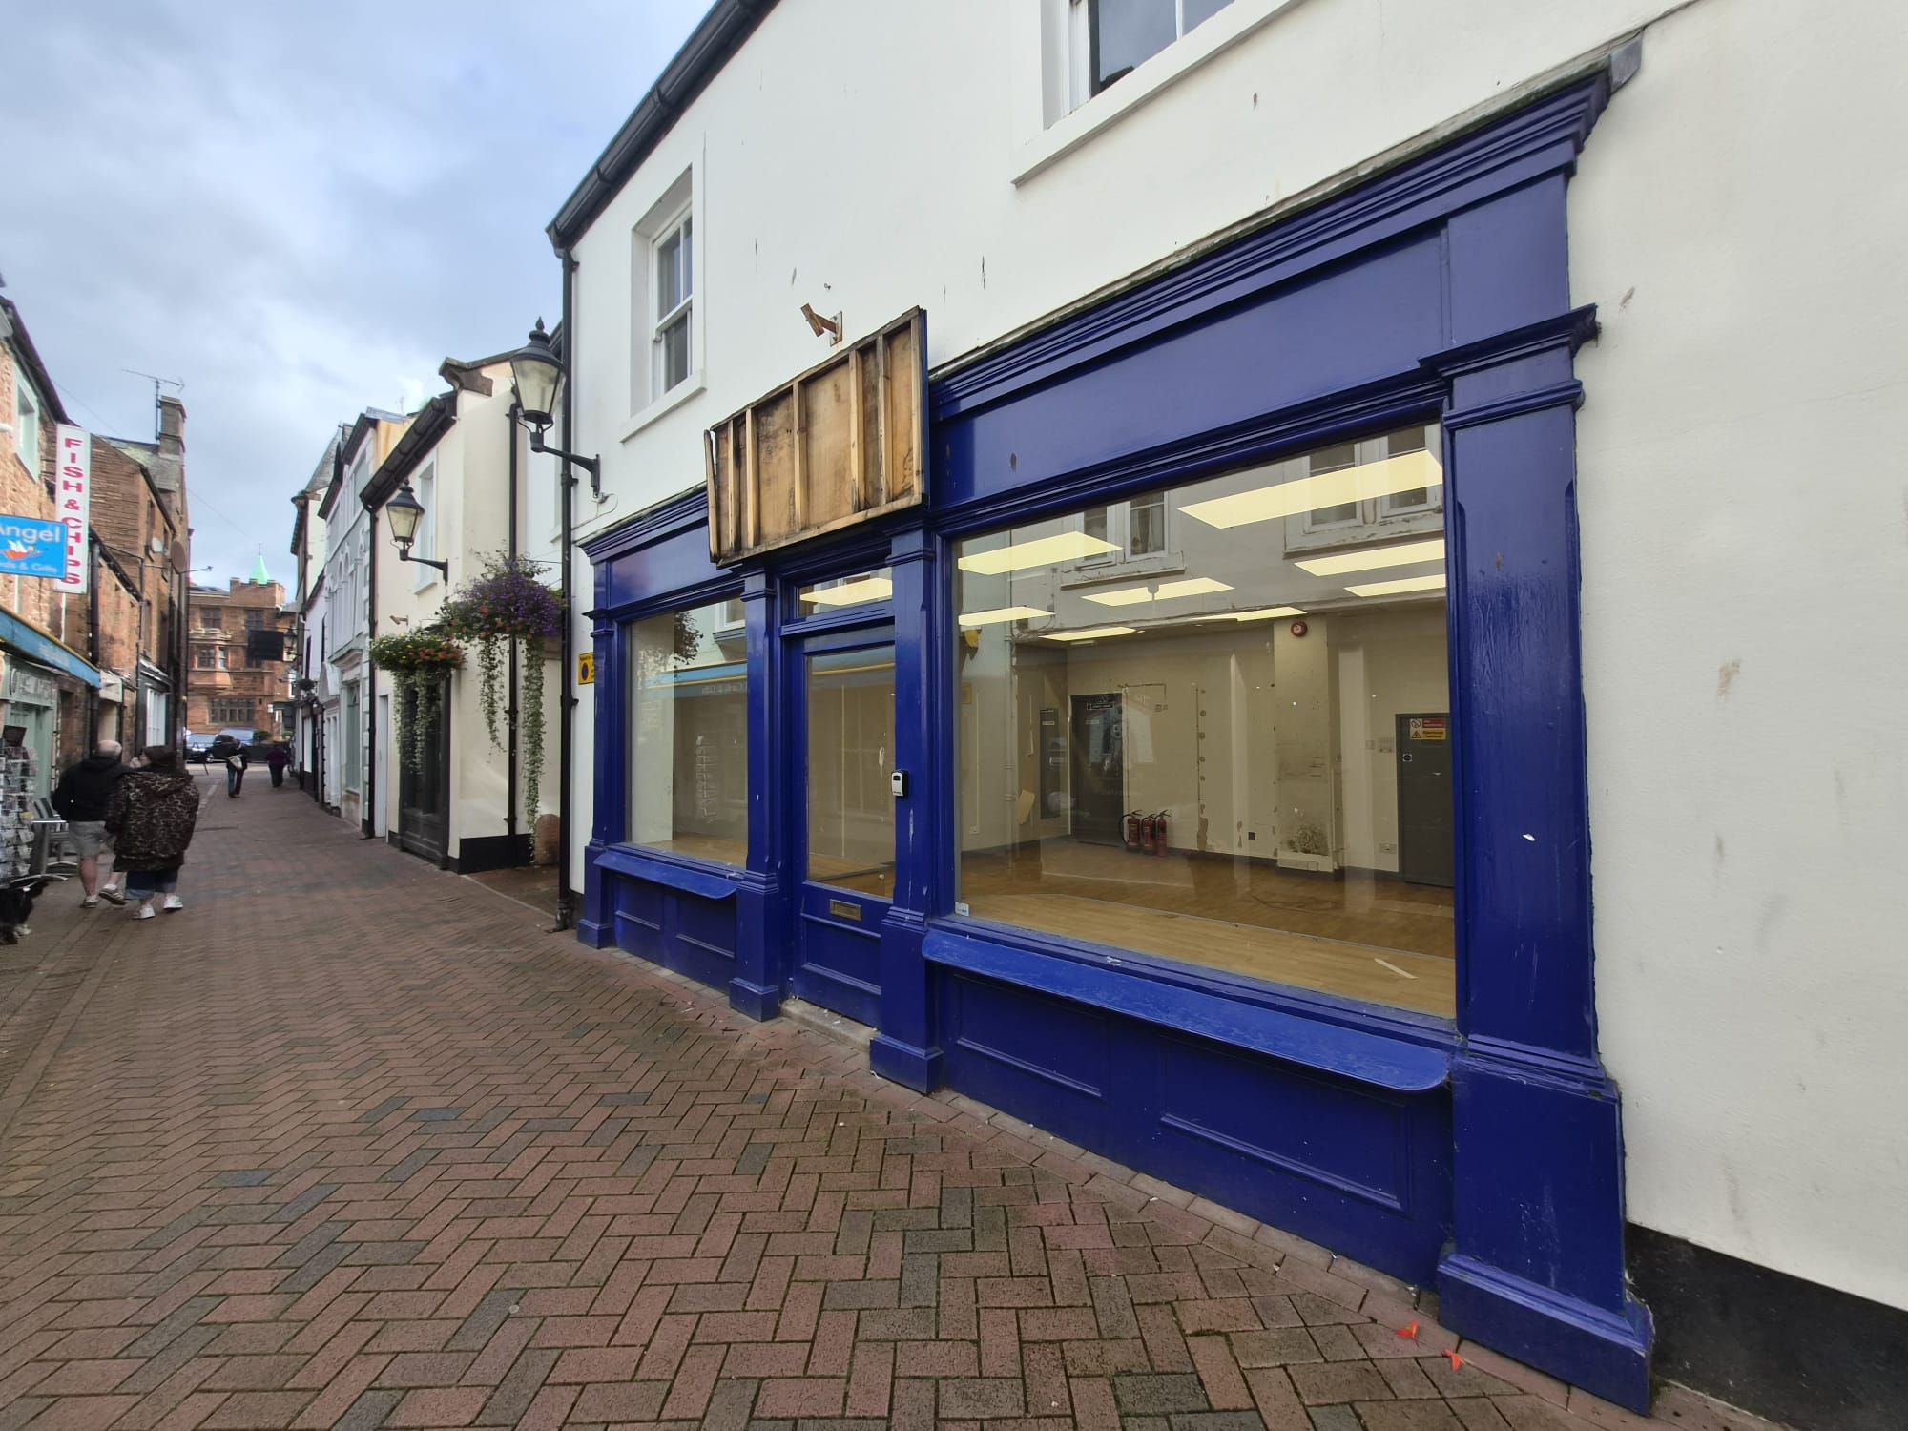

TO LET
Retail Shop
Unit 10 Angel Lane, Angel Square, Penrith, Cumbria, CA11 7BP
SIZE  998 SQ FT / 92.7 SQ M  TOWN CENTRE PROPERTY OVER 2 FLOORS. | ACCESSIBILITY:  - ON-STREET PARKING NEARBY.  - LOCATED ON A PEDESTRIANISED STREET |  | ACCESS DISTANCE:  - PENRITH STATION 300M  - PENRITH RAILWAY STATION-400M  - M6 MOTORWAY -1 MILE
PROPERTY PARTICULARS

AGENCY | ADVICE | VALUE
ACROSS THE NORTH OF ENGLAND

THE PROPERTY.
KEY FEATURES
- 998 SQ FT / 92.7 SQ M | - Located in Town Centre | - High levels of foot traffic | - Located 1 Mile from junction 40 of the M6
LOCATION
Unit 10, Angel Lane is located in the center of Penrith, within the pedestrianized street. Angel Lane has a mixed variety of shops, such as retail shops and cafes.  Penrith is a market town located on the fringe of the Lake District, which attracts high levels of tourism to the area. Penrith is well served bus network which brings tourists from places such as Carlisle, Keswick, Ullswater, and West Cumbria. Penrith Railway Station is located just 400m from the property, and trains run on the west coast main line to major cities including London, Manchester, and Glasgow. | 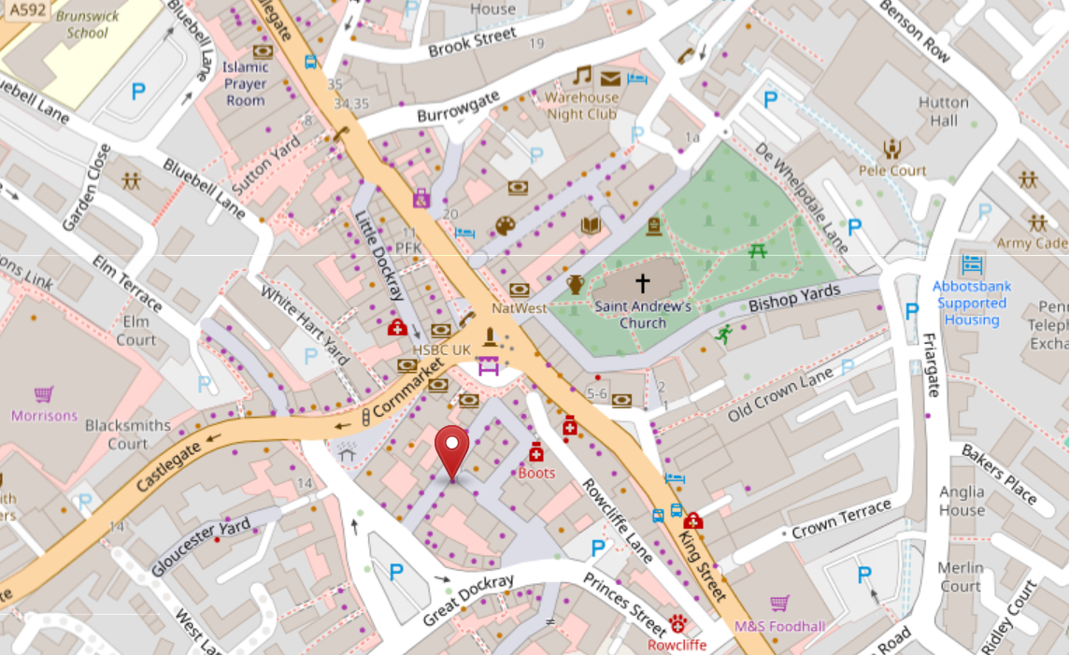
THE PROPERTY
The property comprises of a retail premises that has been most recently used by a well-established business.  The shop is set over 2 floors and offers a total space of around 92.7 SQ M. The ground floor of the property features a large main front room of 37 SQ M, ideal for retail trading. This is due to it benefiting from good visibility and high levels of foot traffic down Angel Lane.  On the upper floor is a spacious storage space of 53 SQ M. The upper floor also includes staff toilet facilities, and kitchen facilities, which provides added convenience.  The property is currently vacant and ready for occupation, providing an opportunity for a new owner or tenant to make the space their own and adapt it to suit their needs. | 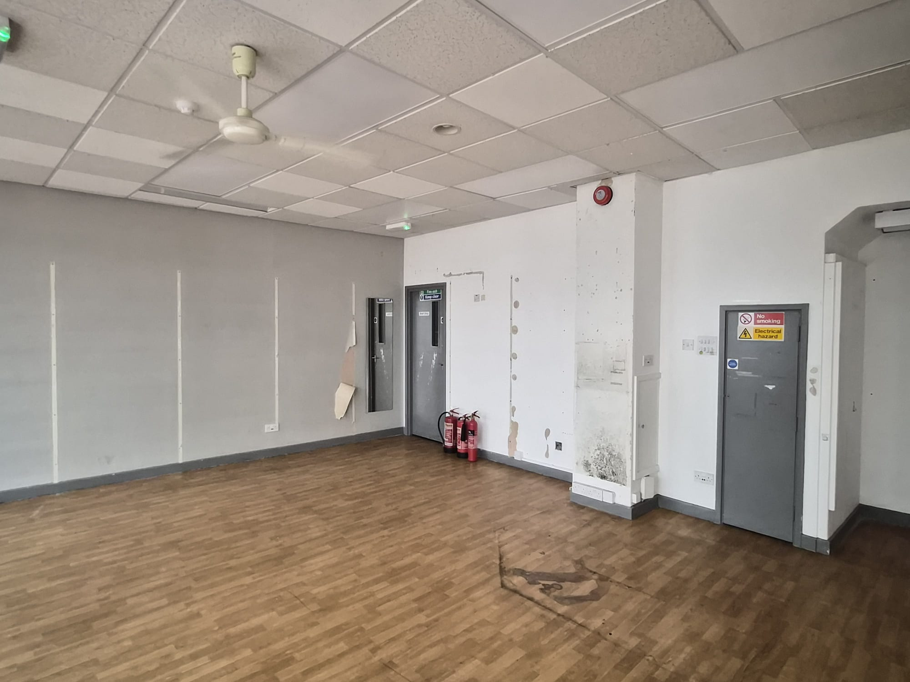
ACCOMMODATION
FLOOR / AREA | SQ FT | SQ M
Ground Floor Retail Space | 398 | 37.00
First Floor Retail Storage | 570 | 53.00
First Floor Staff W/C | 30 | 2.8
TOTAL | 998 | 92.7
Property Features:
SERVICES: We understand that the property is connected to a mains electricity and water supply.
PARKING / LOADING: The property is located on a pedestrianized street. On-street disk parking can be found nearby.
EPC: Unit 10, Angel Lane has an EPC of B. The current EPC expires on 25/07/2032.

AGENCY | ADVICE | VALUE
ACROSS THE NORTH OF ENGLAND

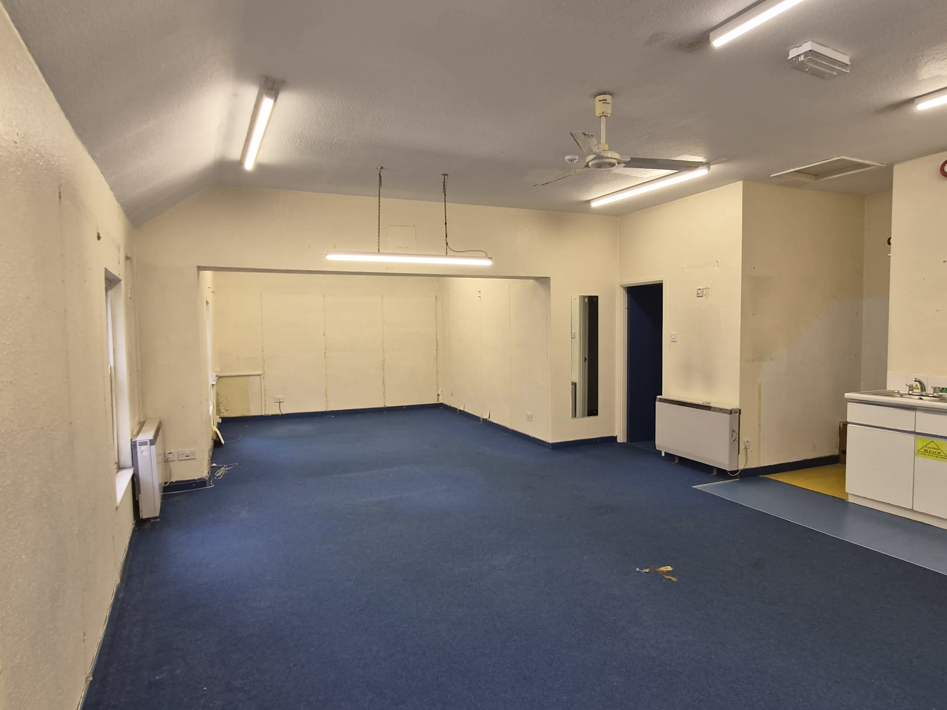
PHOTOGRAPHS
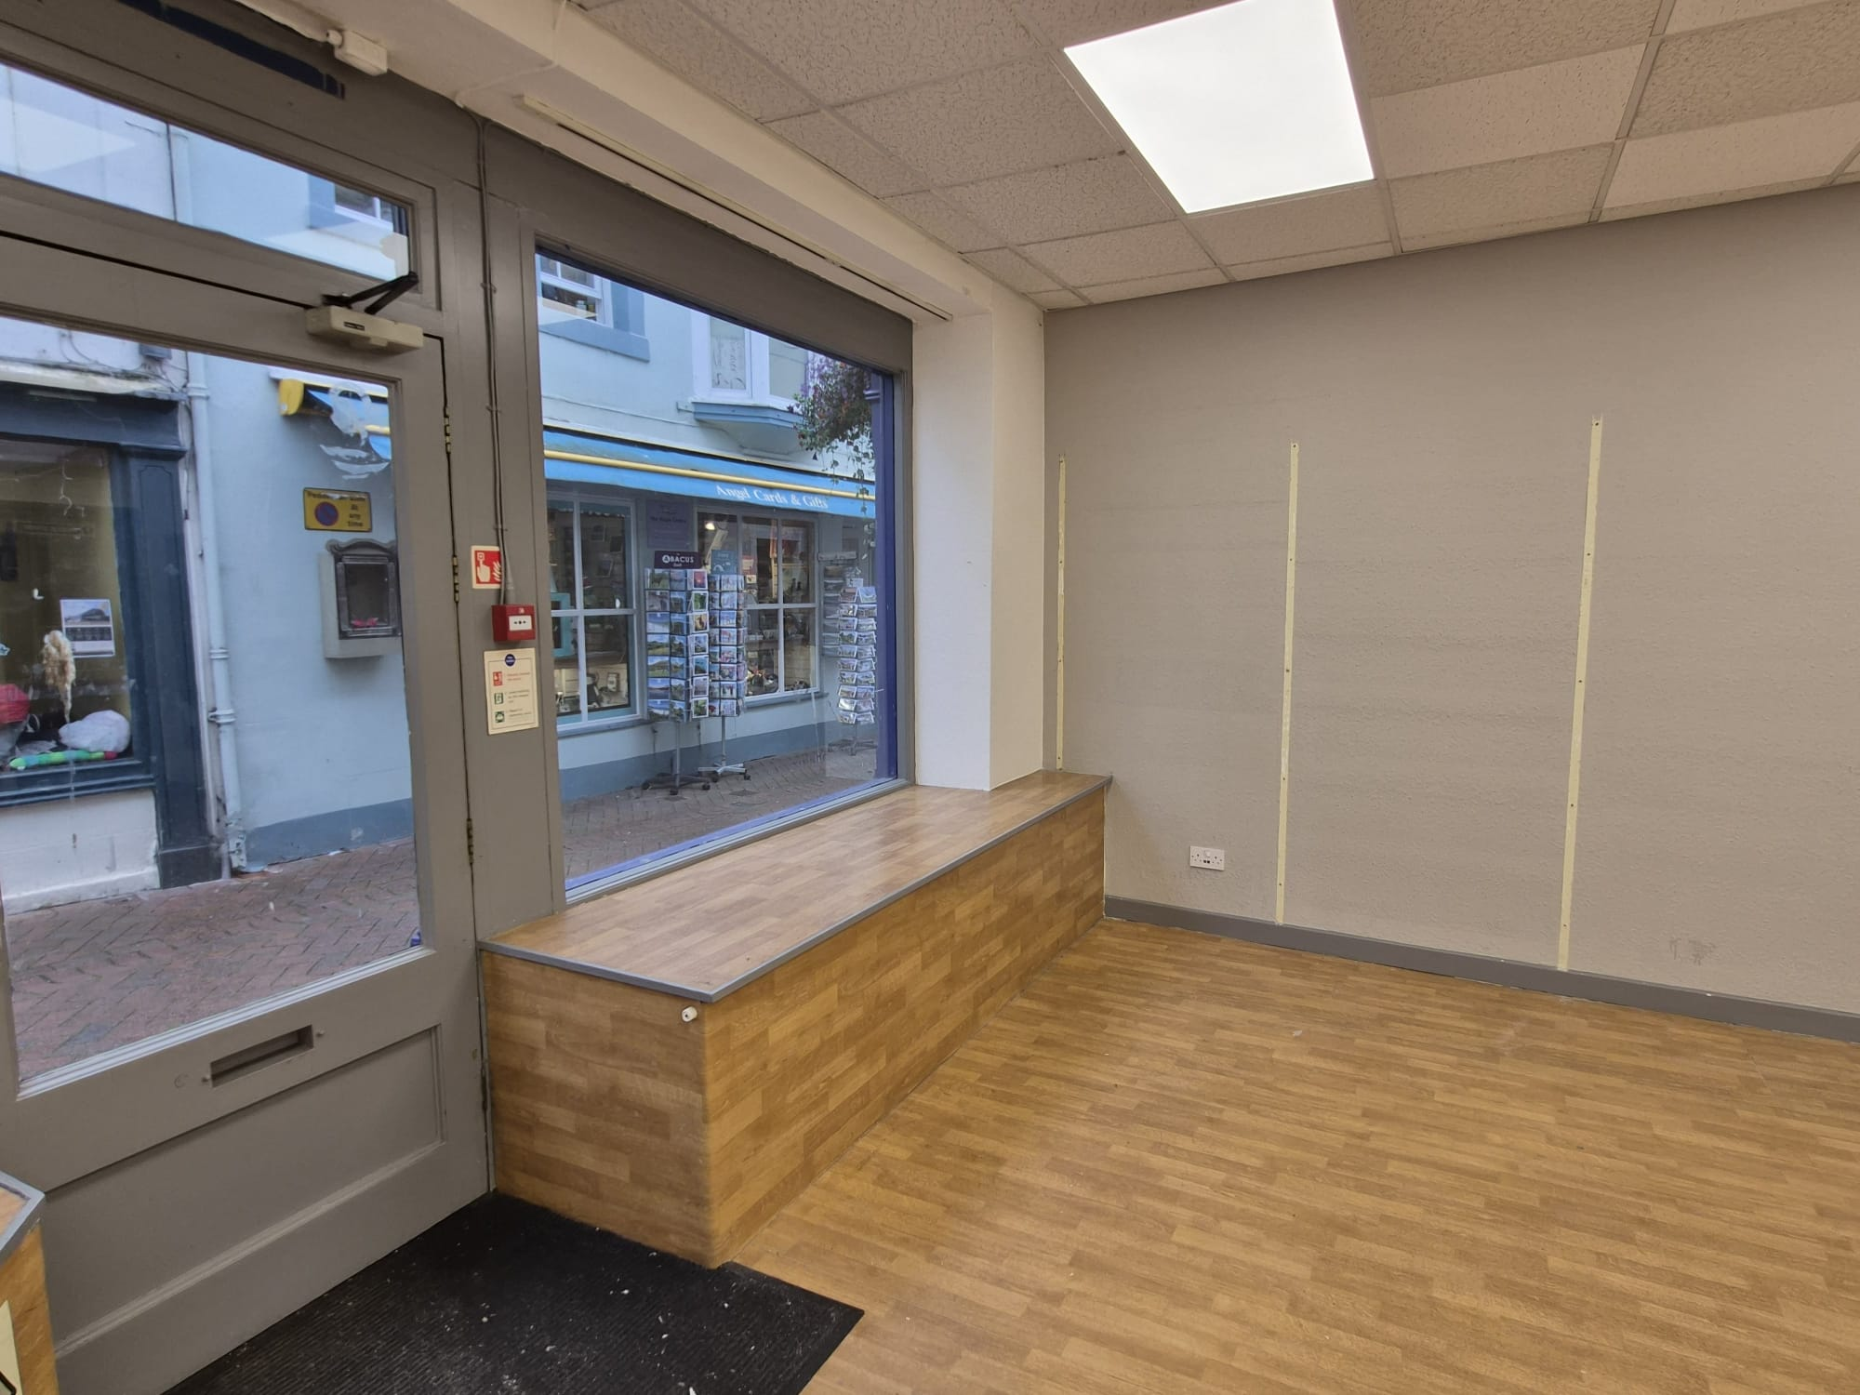

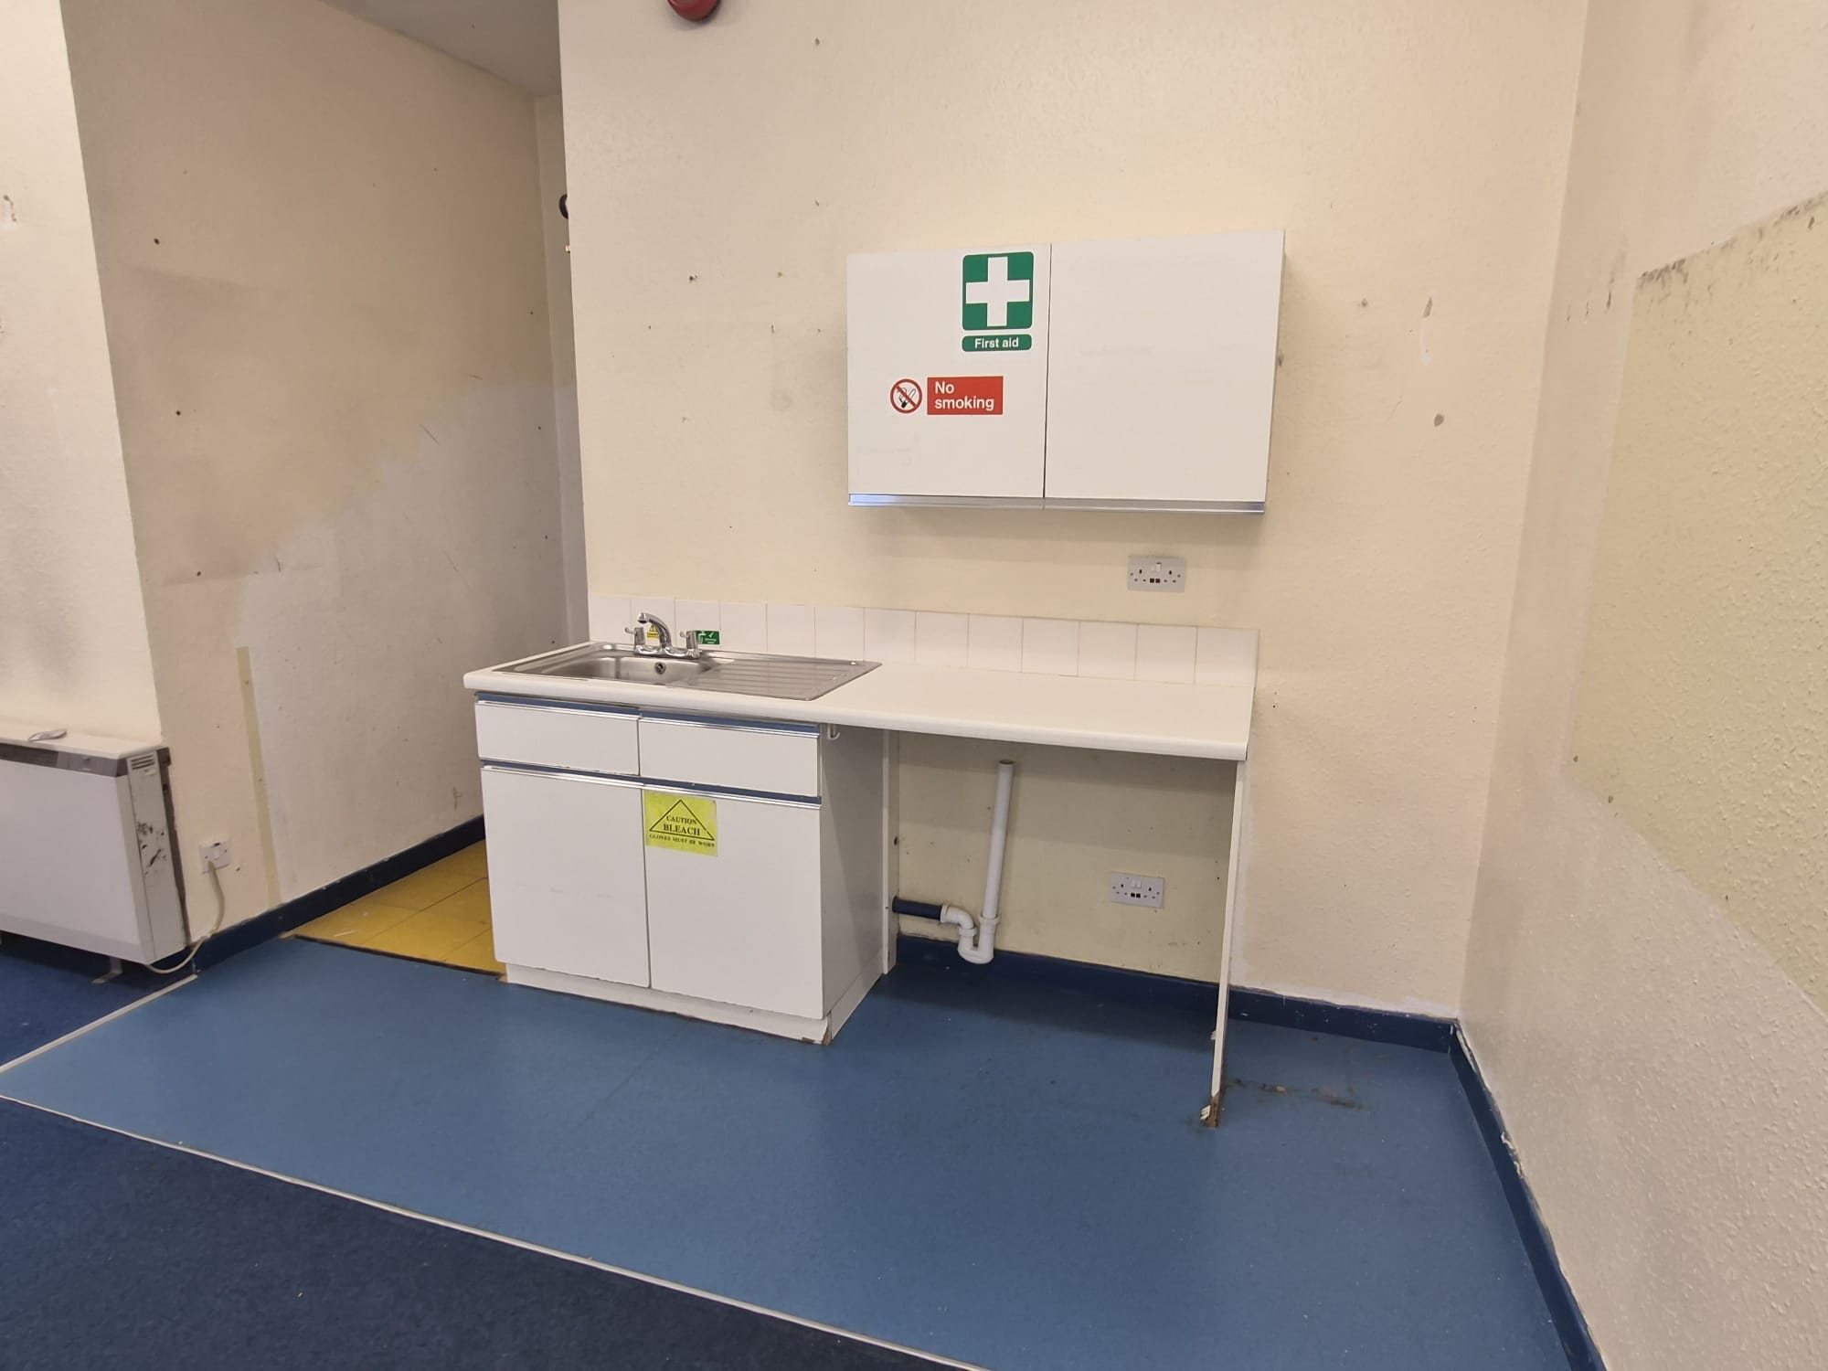  [INSERT PROPERTY PHOTOGRAPH] |  | 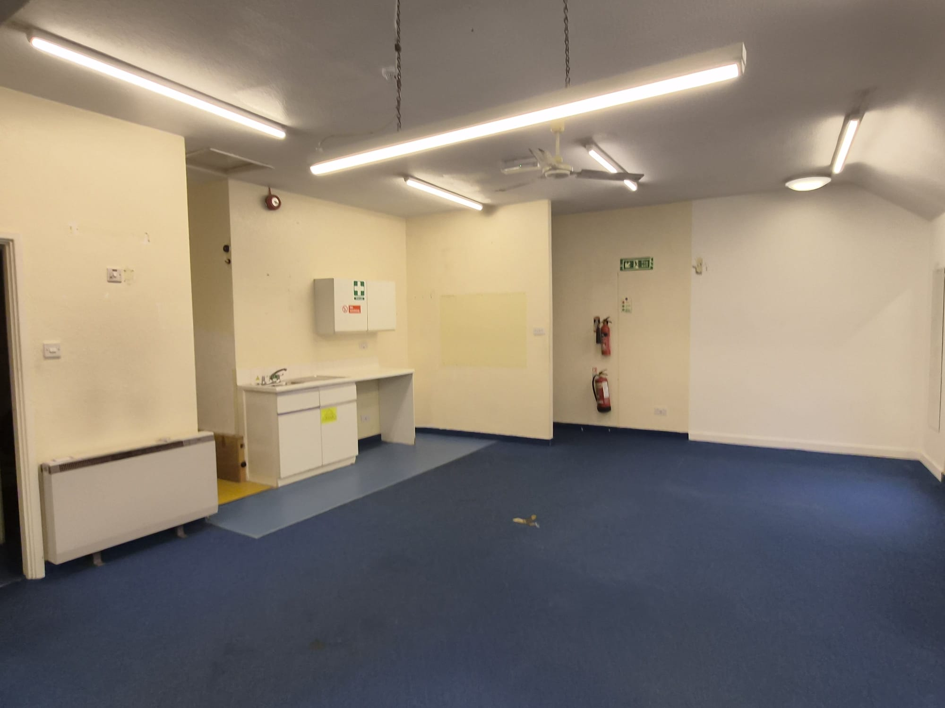  [INSERT PROPERTY PHOTOGRAPH]
TERMS  The property is available for a term of years to be agreed. | RENT / PRICE  £15,000 + VAT Per Annum  Service Charge Budget: £1927.47 + VAT Per Annum.  The Annual Insurance for the property is approximately £250 Per Annum |  | VAT  We understand that VAT is not applicable.  Prospective purchasers and tenants should satisfy themselves as to the VAT position and seek appropriate professional advice.
BUSINESS RATES  No Business Rates information found. | EPC  Unit 10, Angel Lane has an EPC of B. The current EPC expires on 25/07/2032. |  | LEGAL COSTS  Please enquire regarding legal costs.
VIEWING  Strictly by appointment only.  Contact Mere Agency  Email: George.chambers@merecommercial.co.uk | FURTHER INFORMATION / CONTACT  Richard Butterworth  01768 483 498  info@merecommercial.co.uk  merecommercial.co.uk
These particulars are for general information purposes only and do not represent an offer of contract or part of one. Mere Commercial Services has made every attempt to ensure that the particulars and other information provided are as accurate as possible and are not intended to amount to advice on which you should rely on being factually accurate. You should not assume that the property has all necessary planning, building regulations, or other consents and Mere Commercial Services have not tested any services, facilities, or equipment. Any measurements or distances given are approximate only. Purchasers must satisfy themselves of all the aforementioned by independent inspection or otherwise.

